**Atma Ram Sanatan Dharma College**

University of Delhi

Submitted By –

Anshul Verma

College Roll No – 19/78065

B.Sc. (Hons) Computer Science

Submitted To –

Ms. Parul Jain

Department of Computer Science

Programming in Java Assignments

Index

|  |  |  |
| --- | --- | --- |
| S.No. | Topic | Page No. |
| 1. | Week #1 Assignment | 02 - 08 |
| 2. | Week #2 Assignment | 09 - 15 |
| 3. | Week #3 Assignment | 16 - 22 |
| 4. | Week #4 Assignment | 23 - 29 |
| 5. | Week #5 Assignment | 30 - 34 |
| 6. | Week #6 Assignment | 35 - 38 |

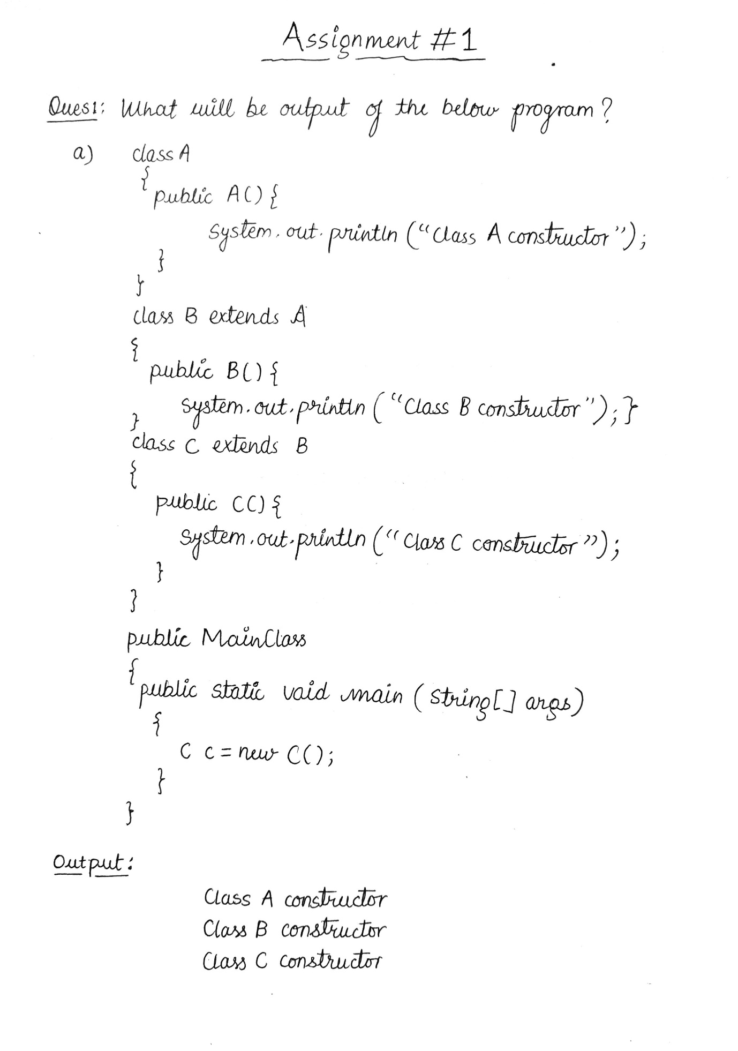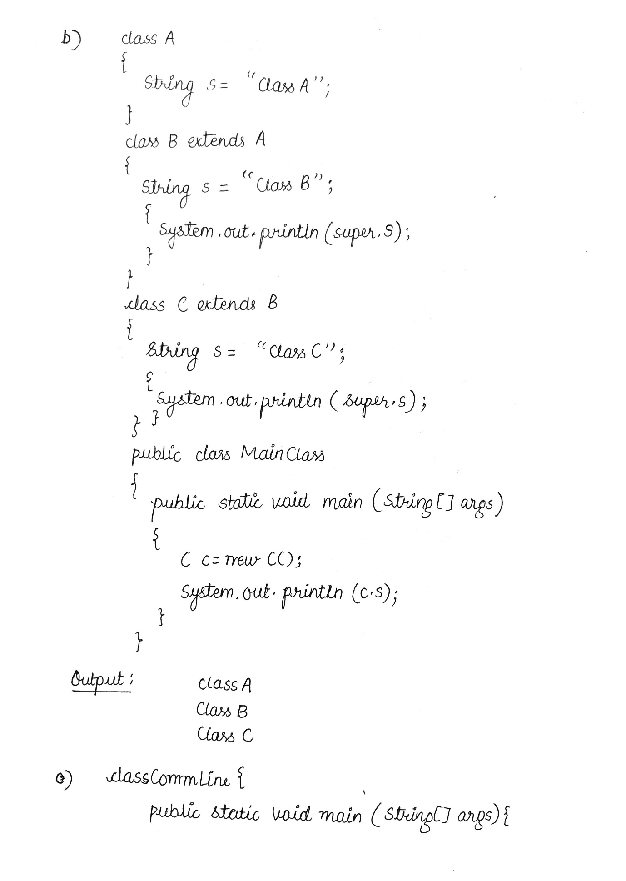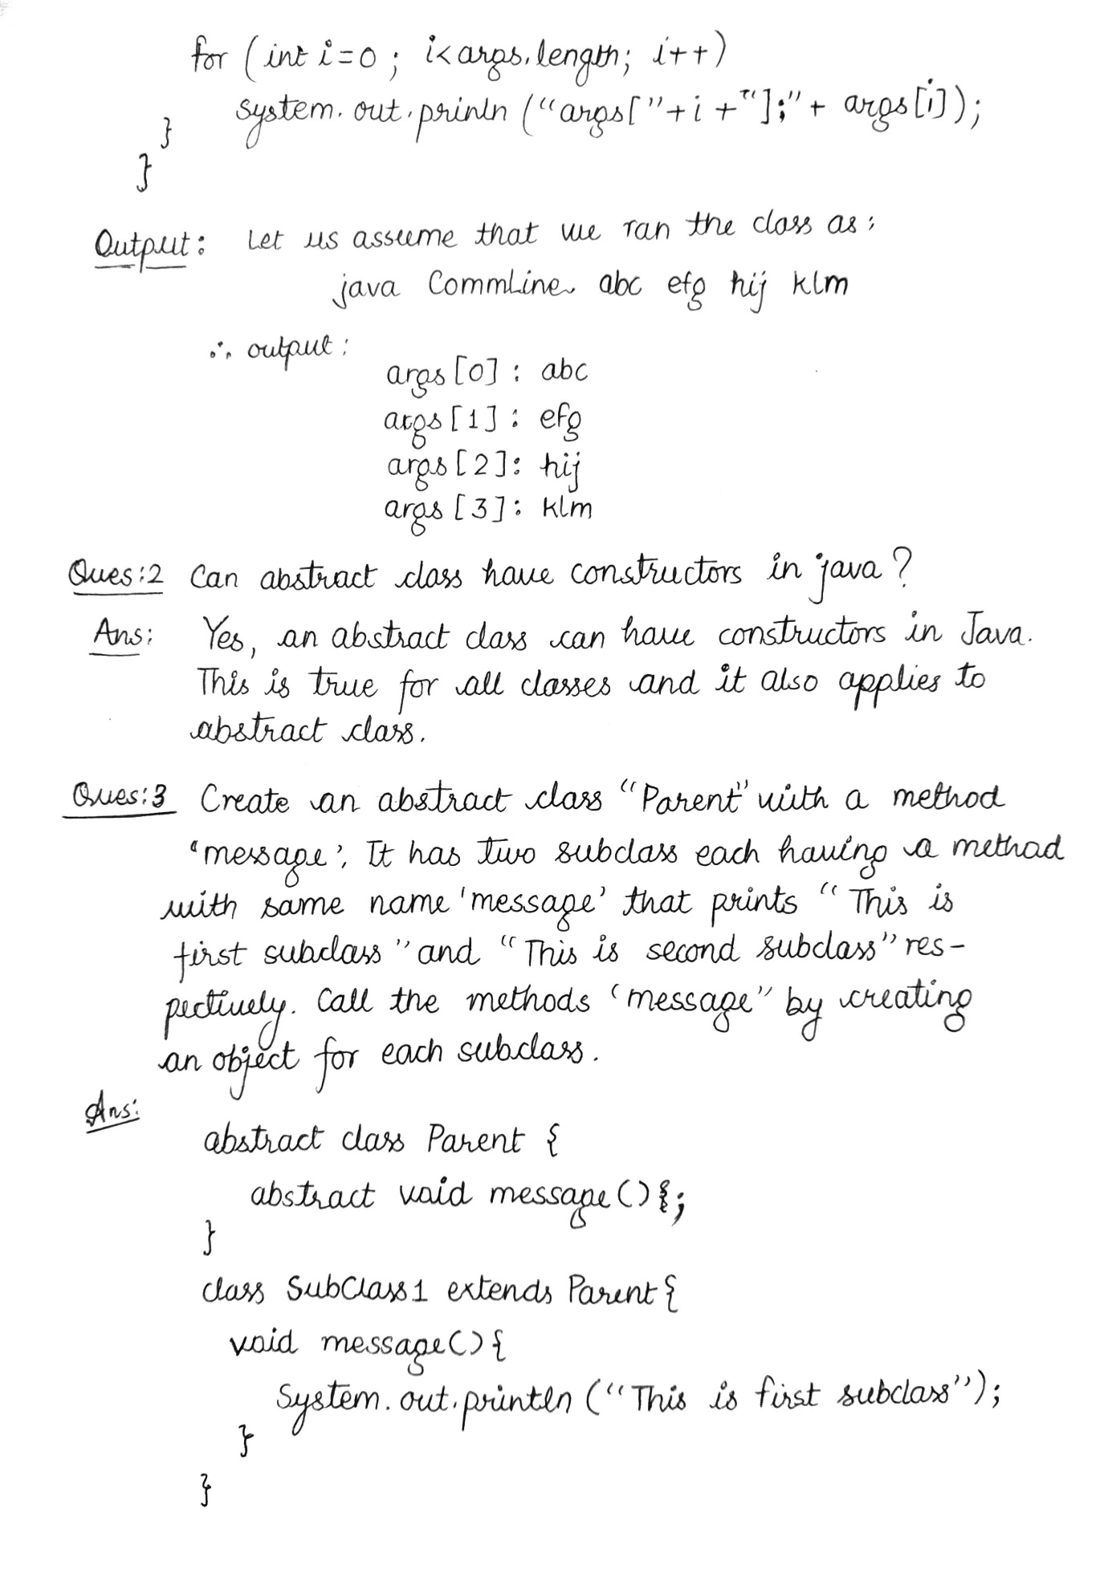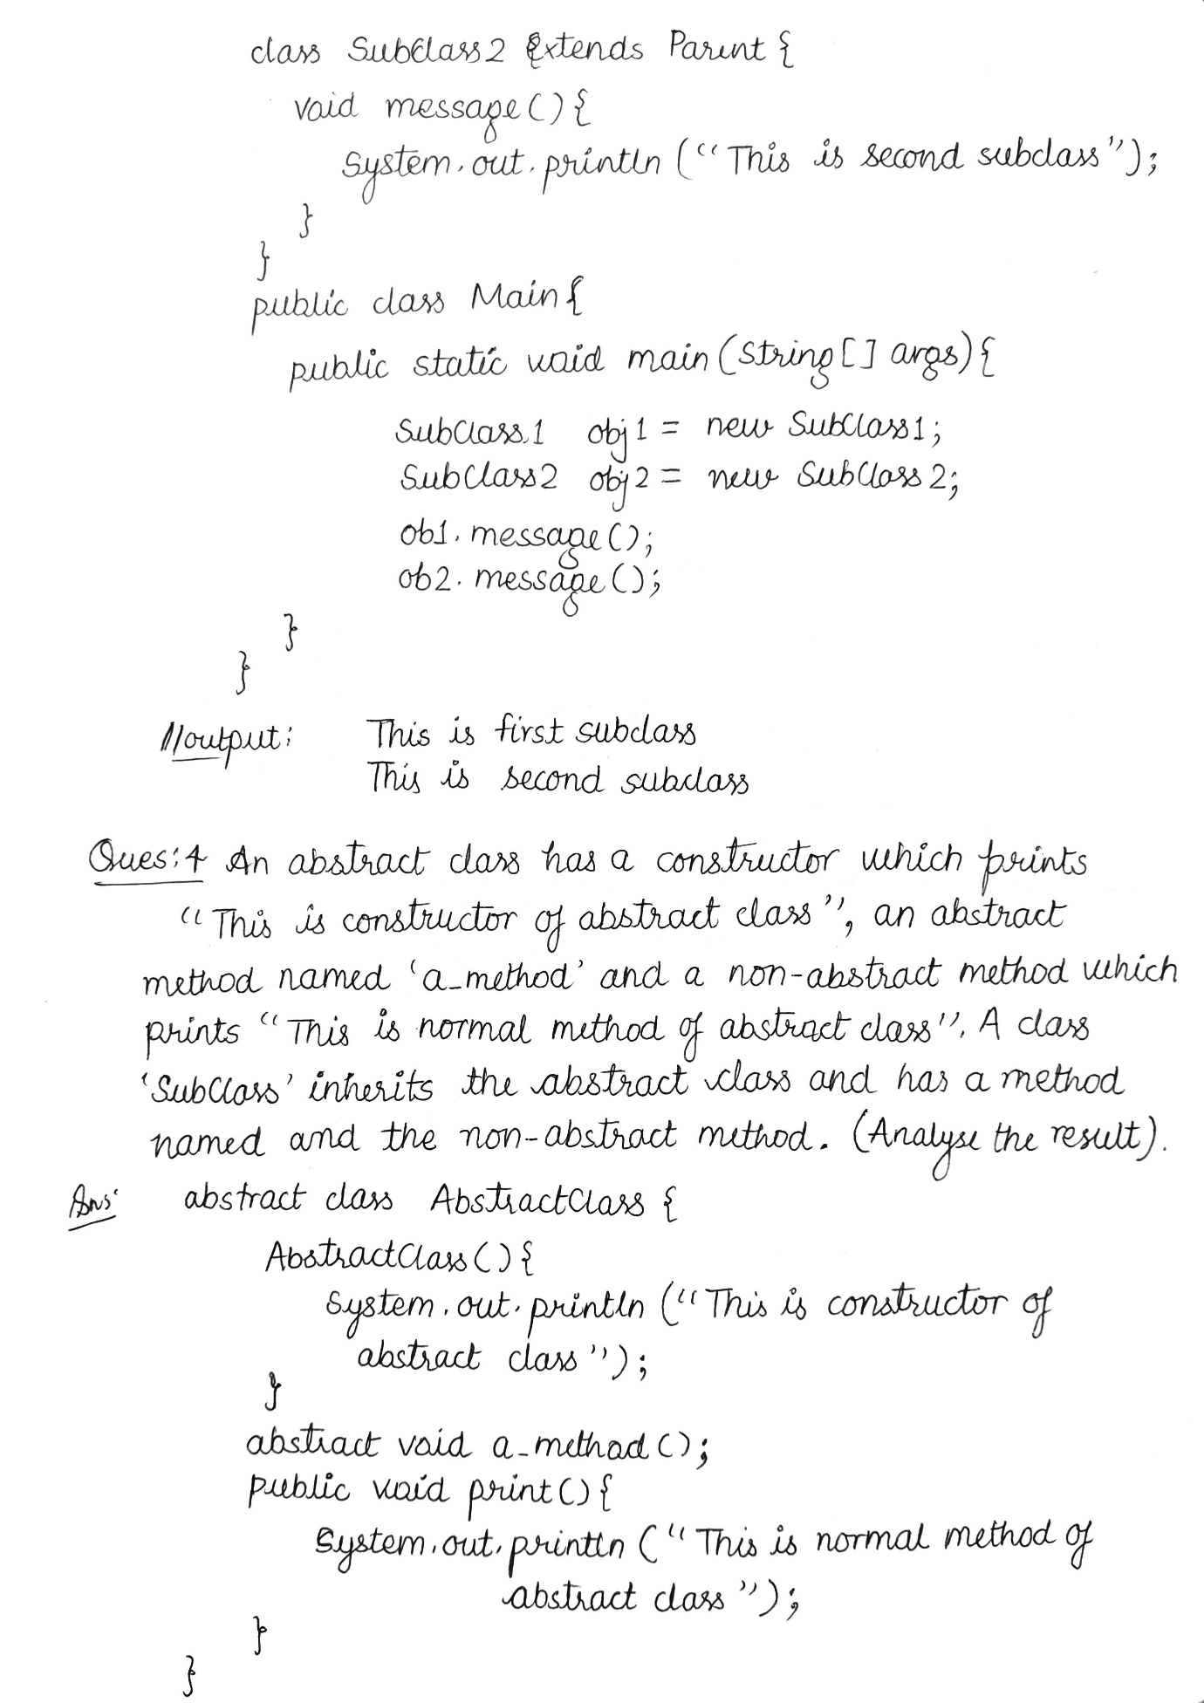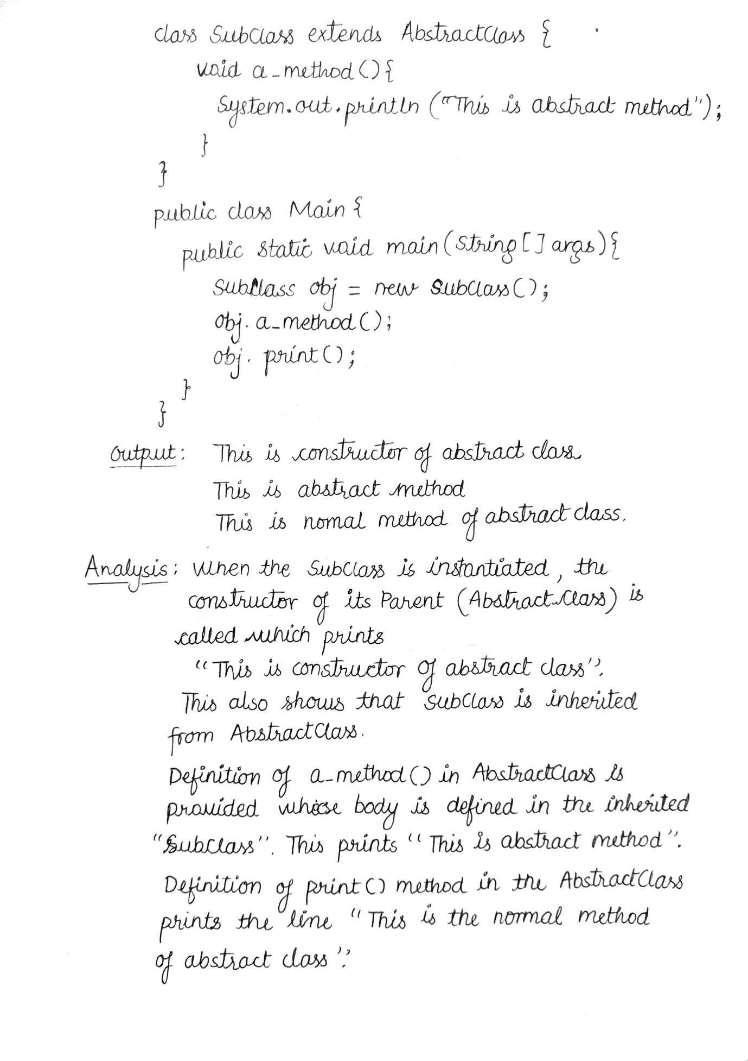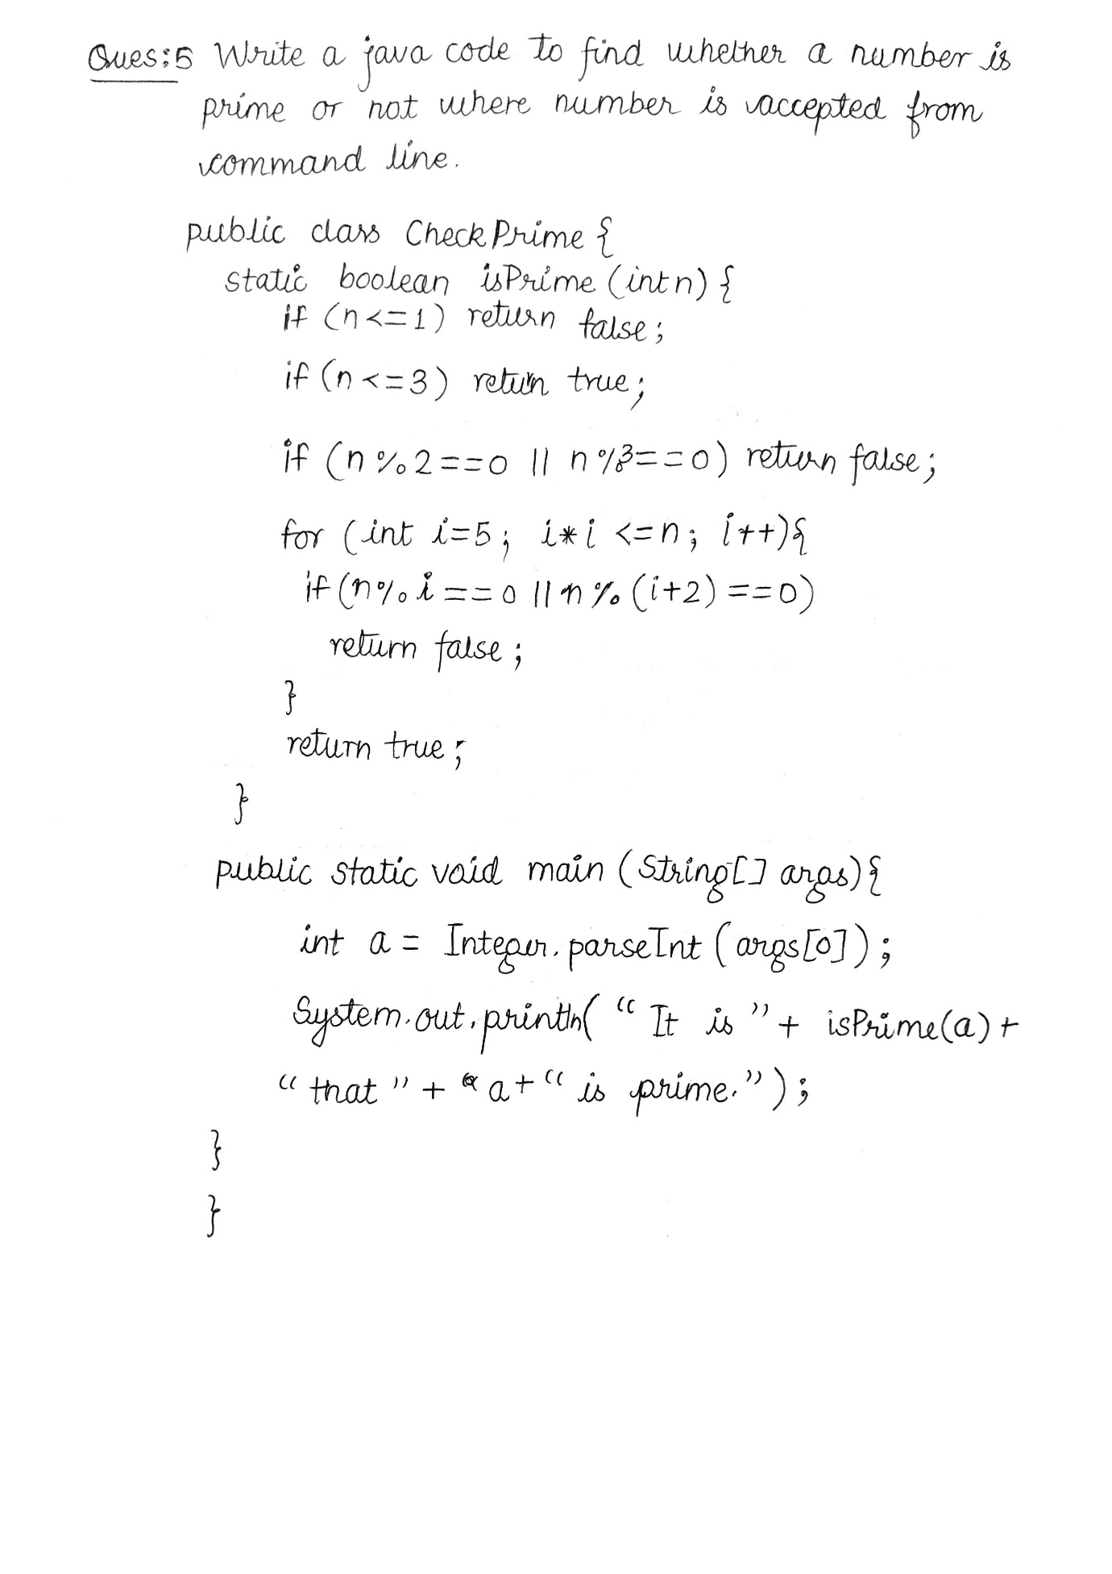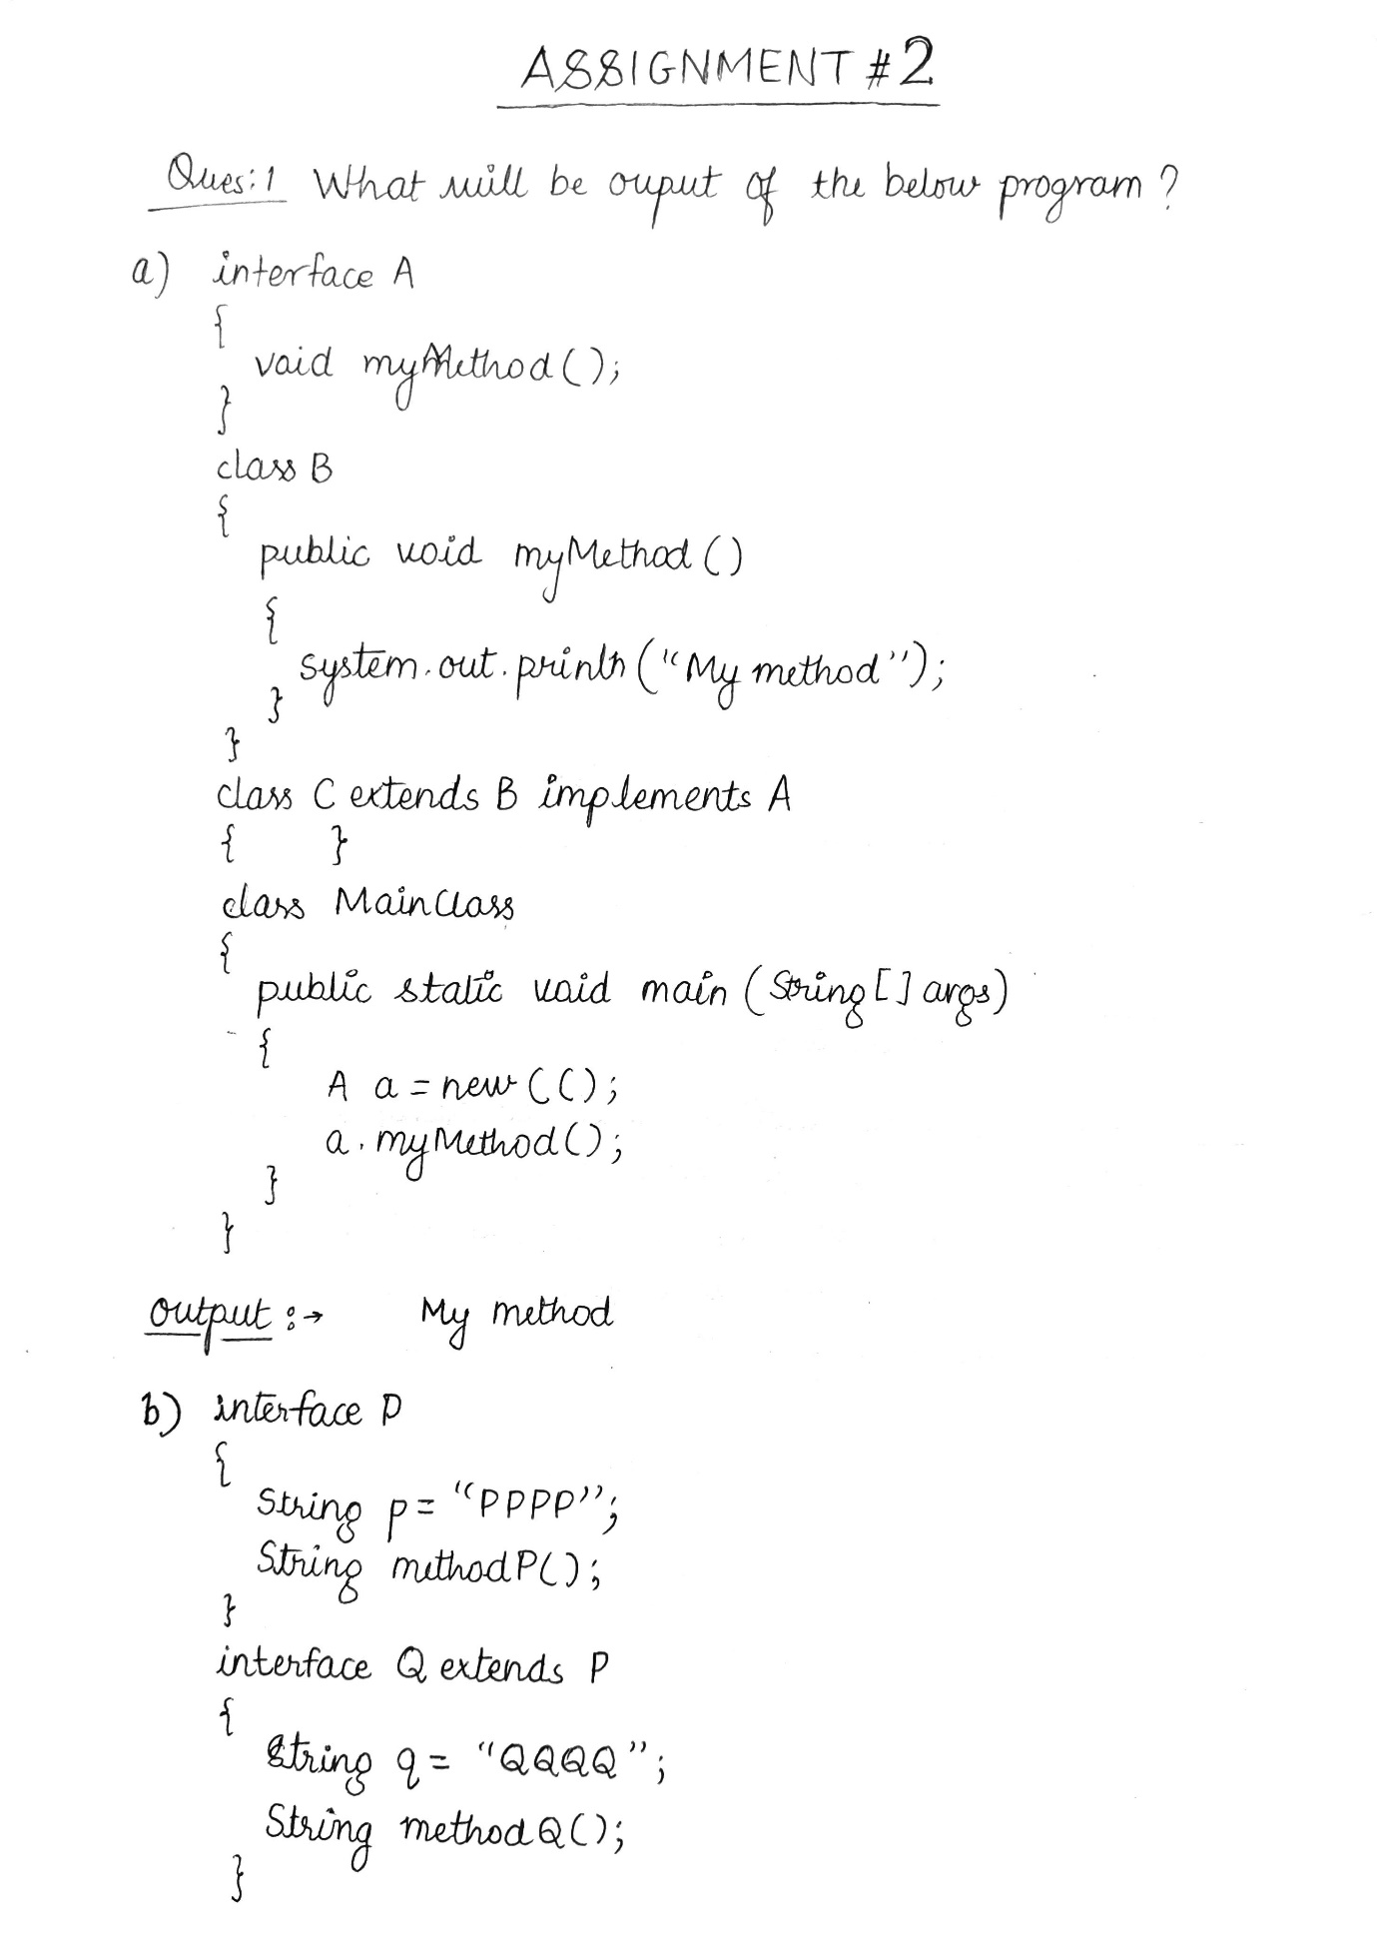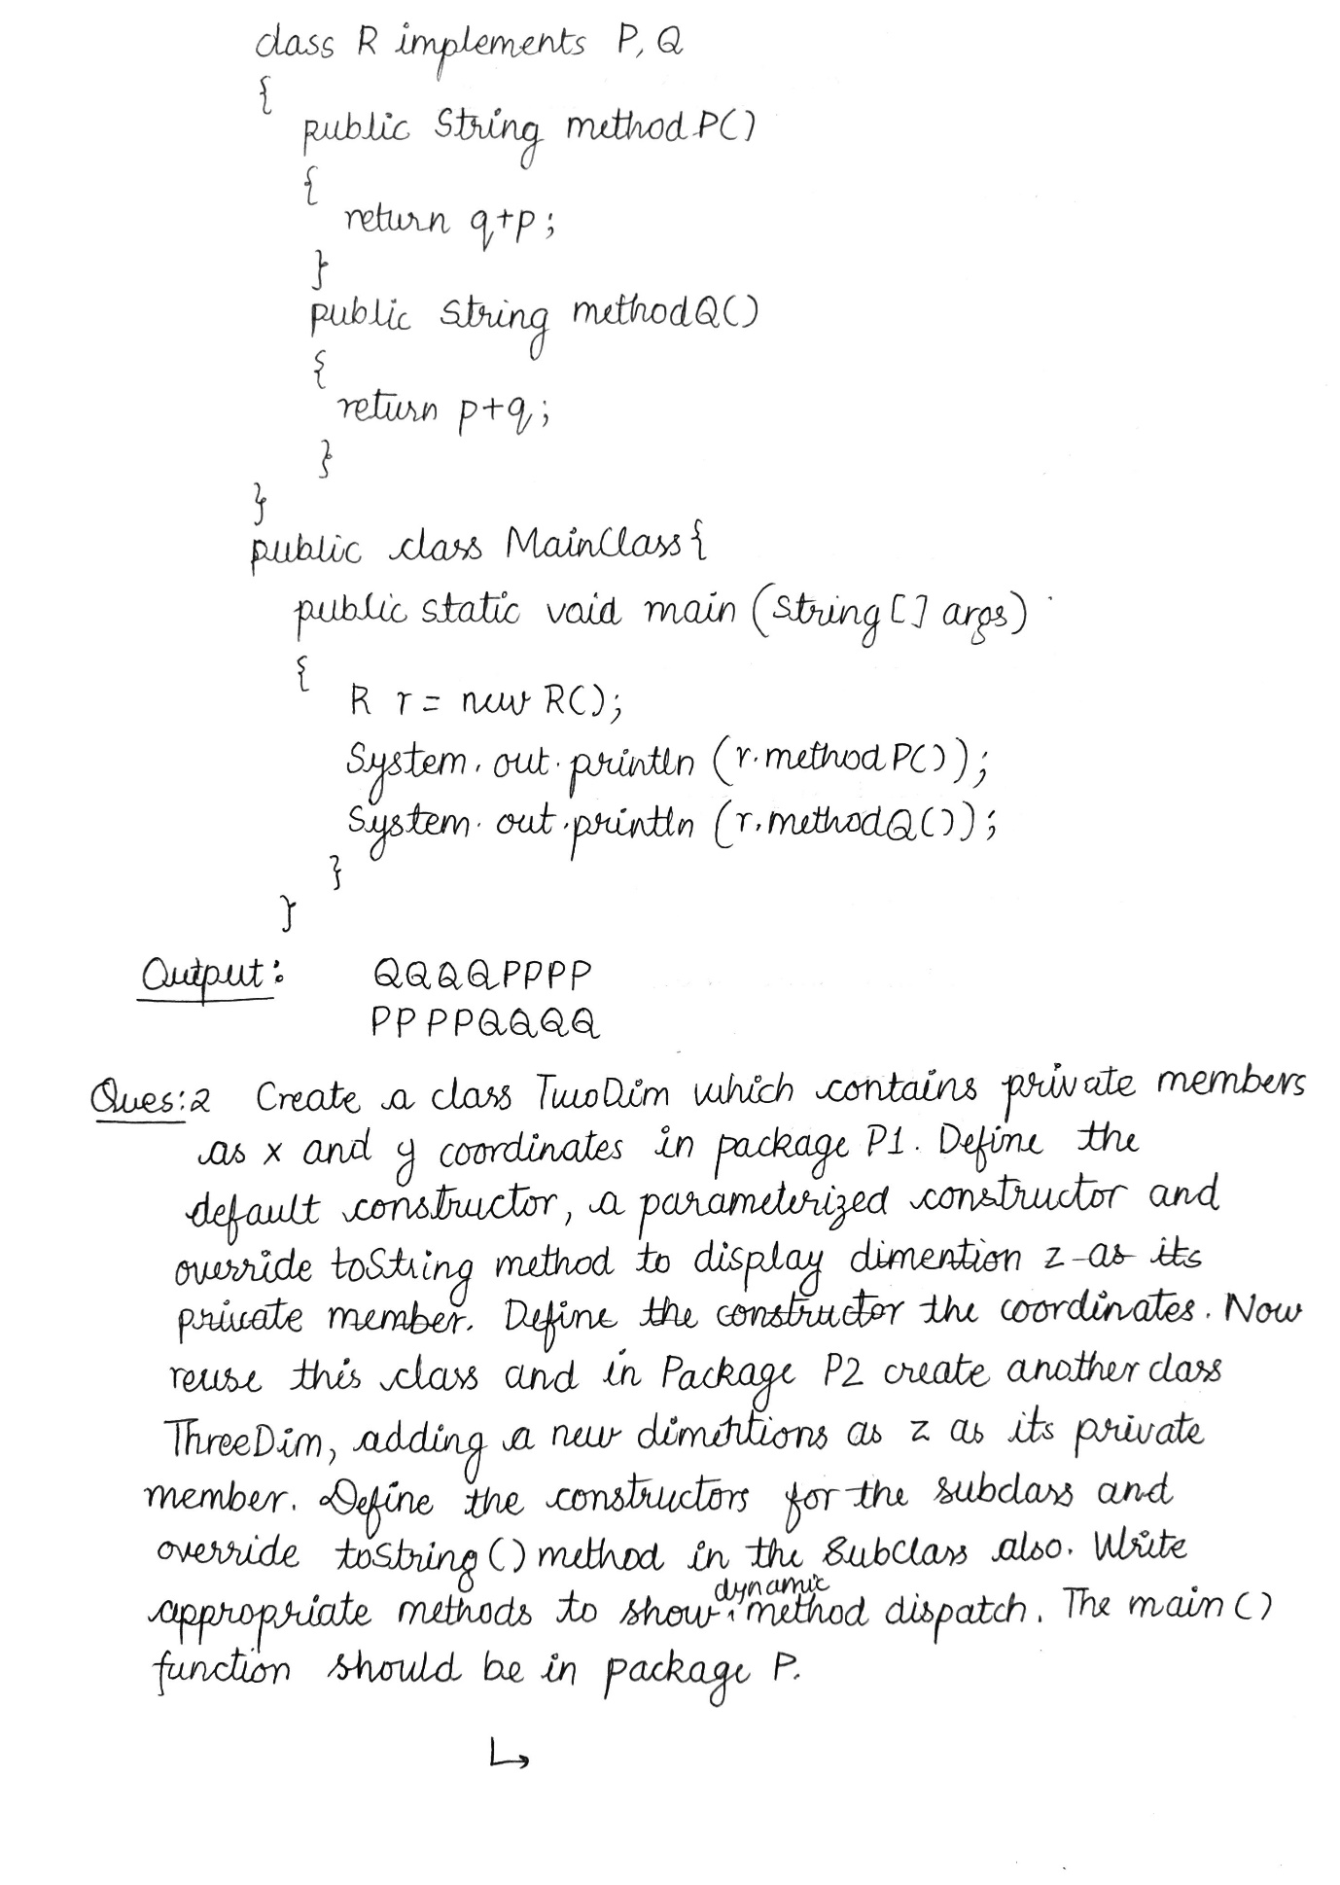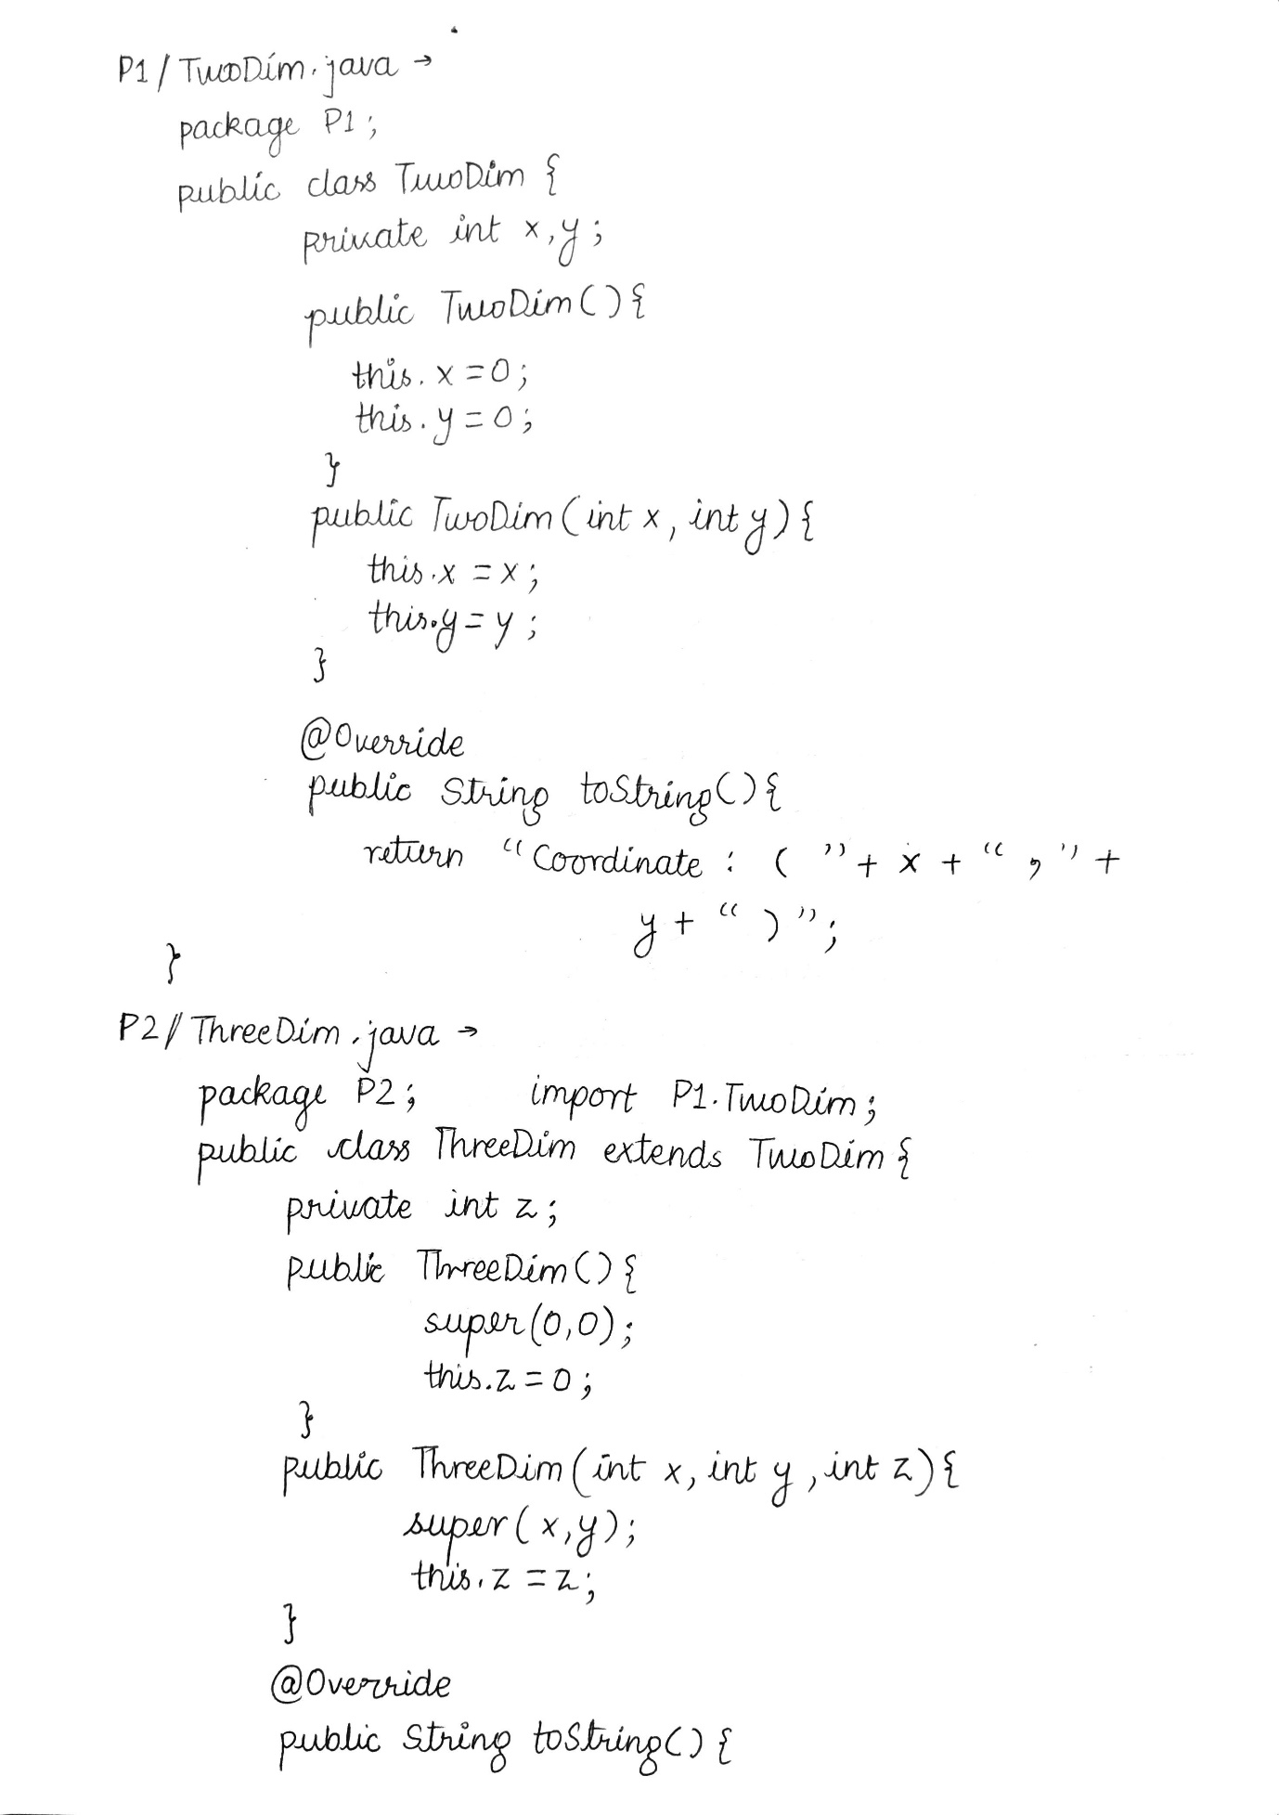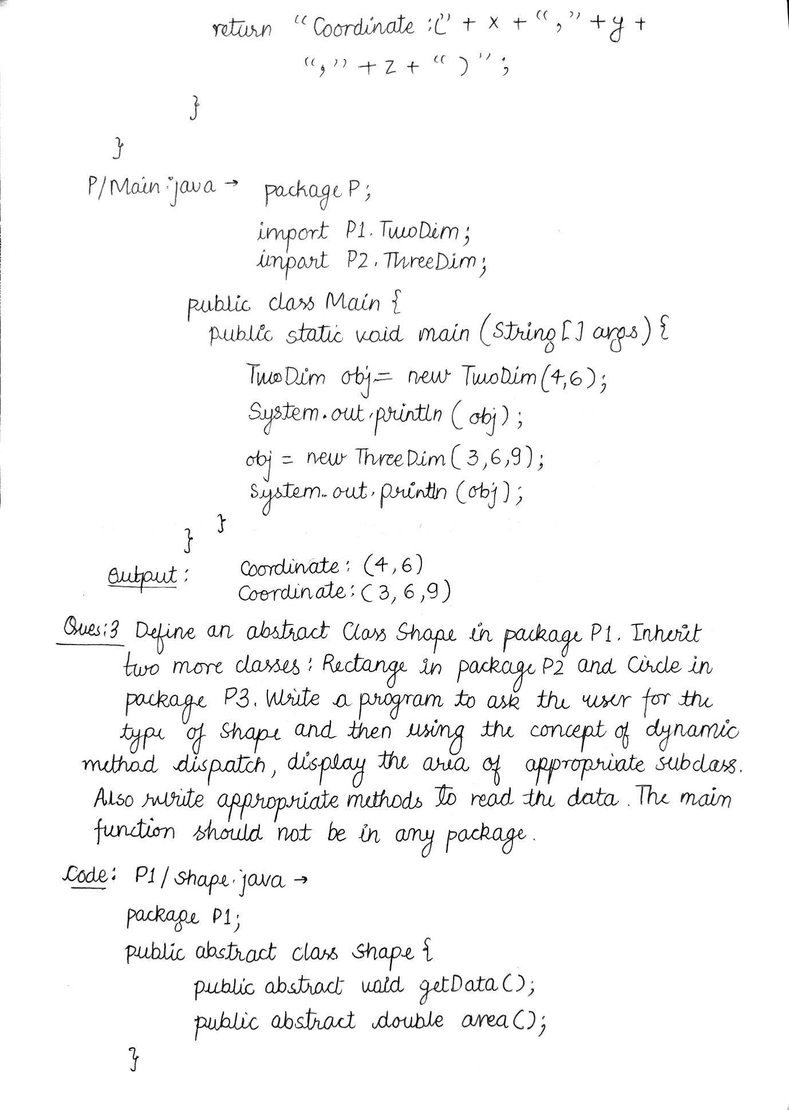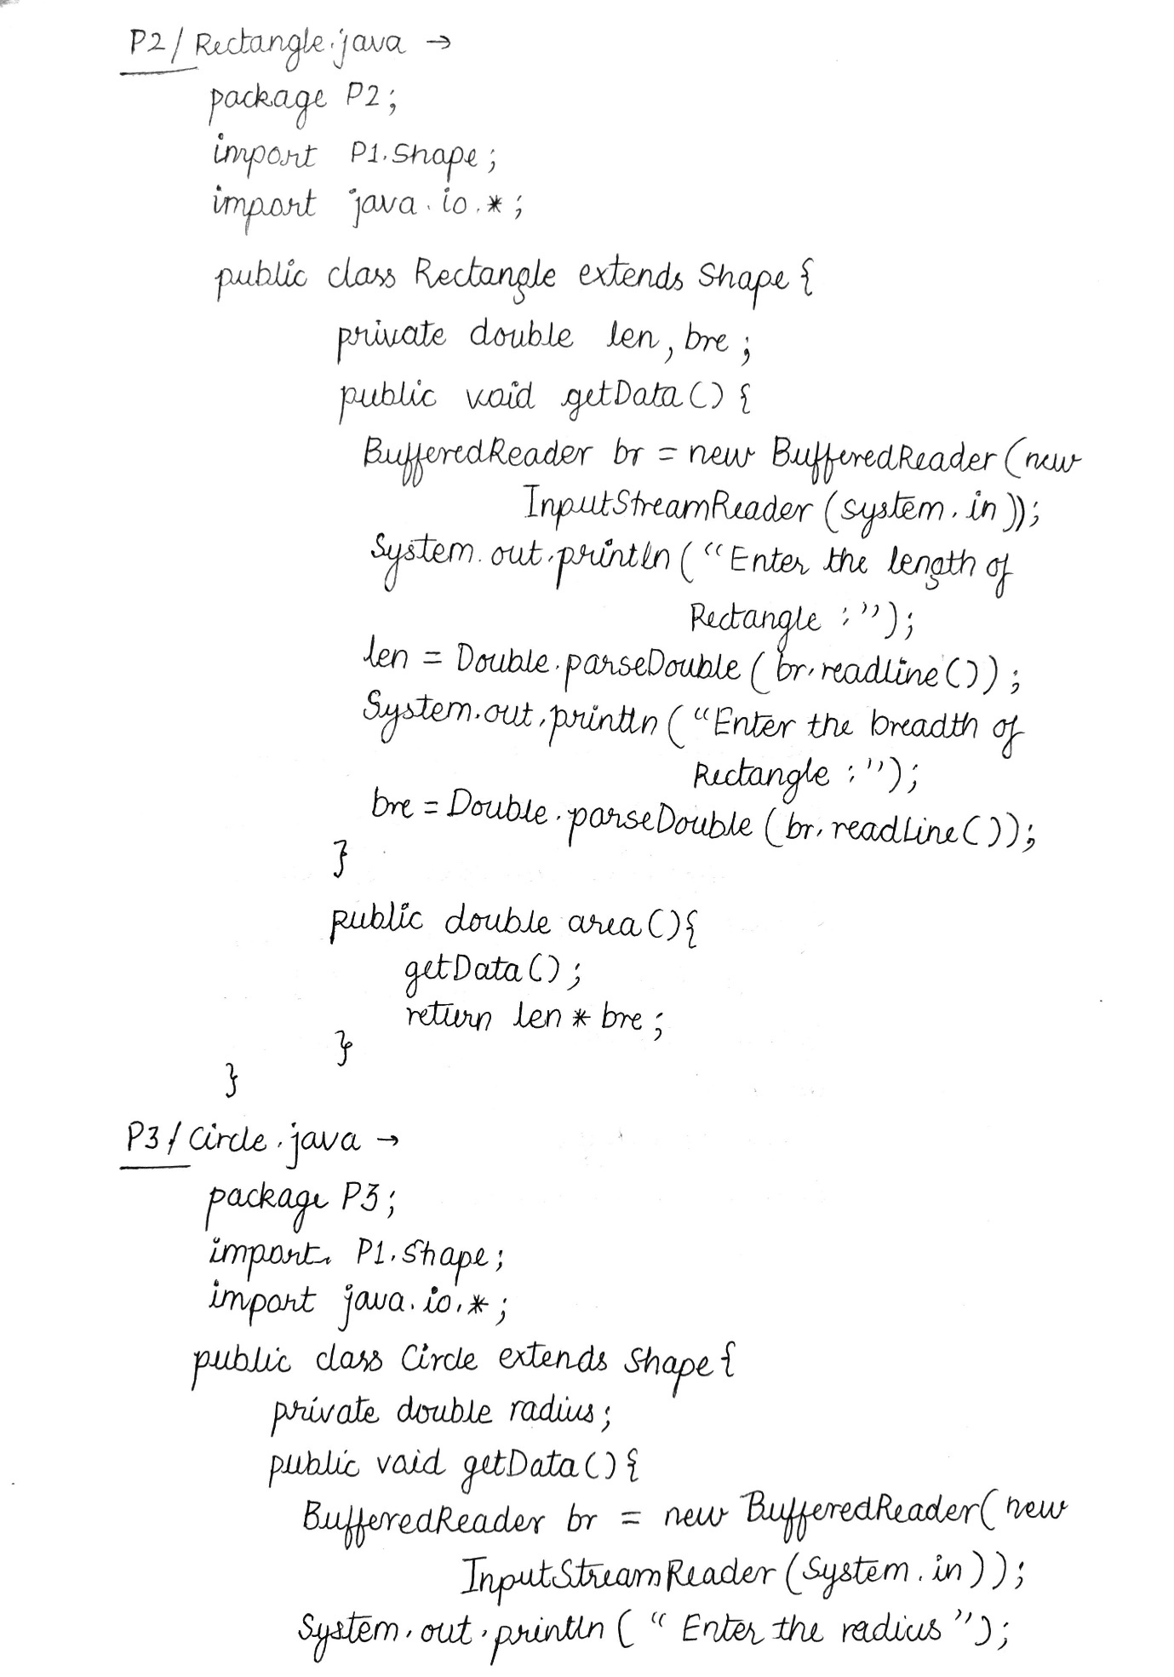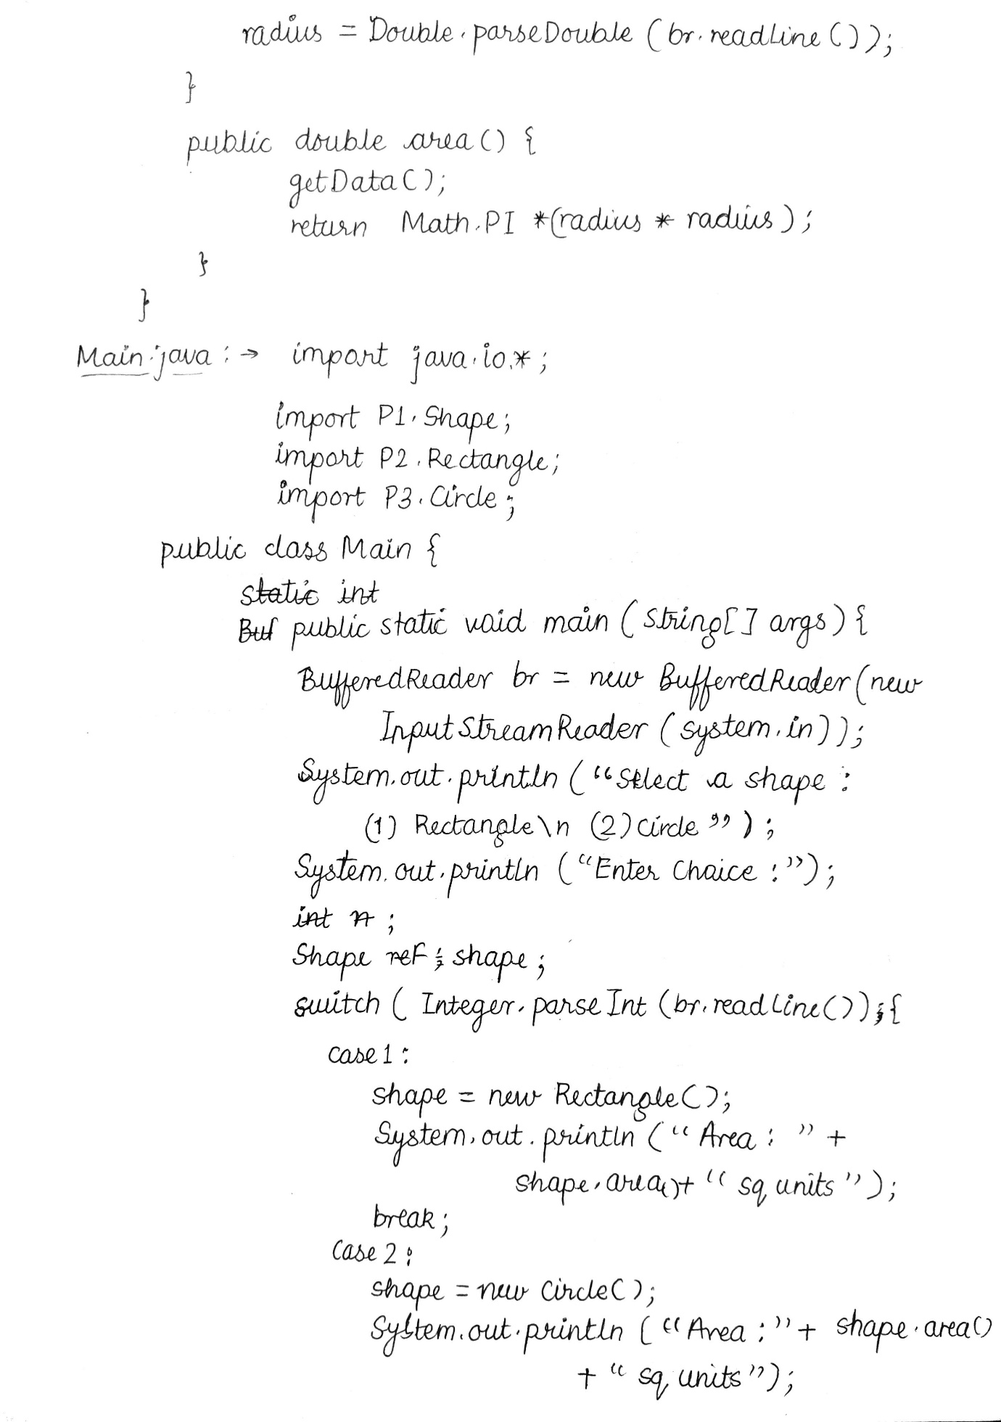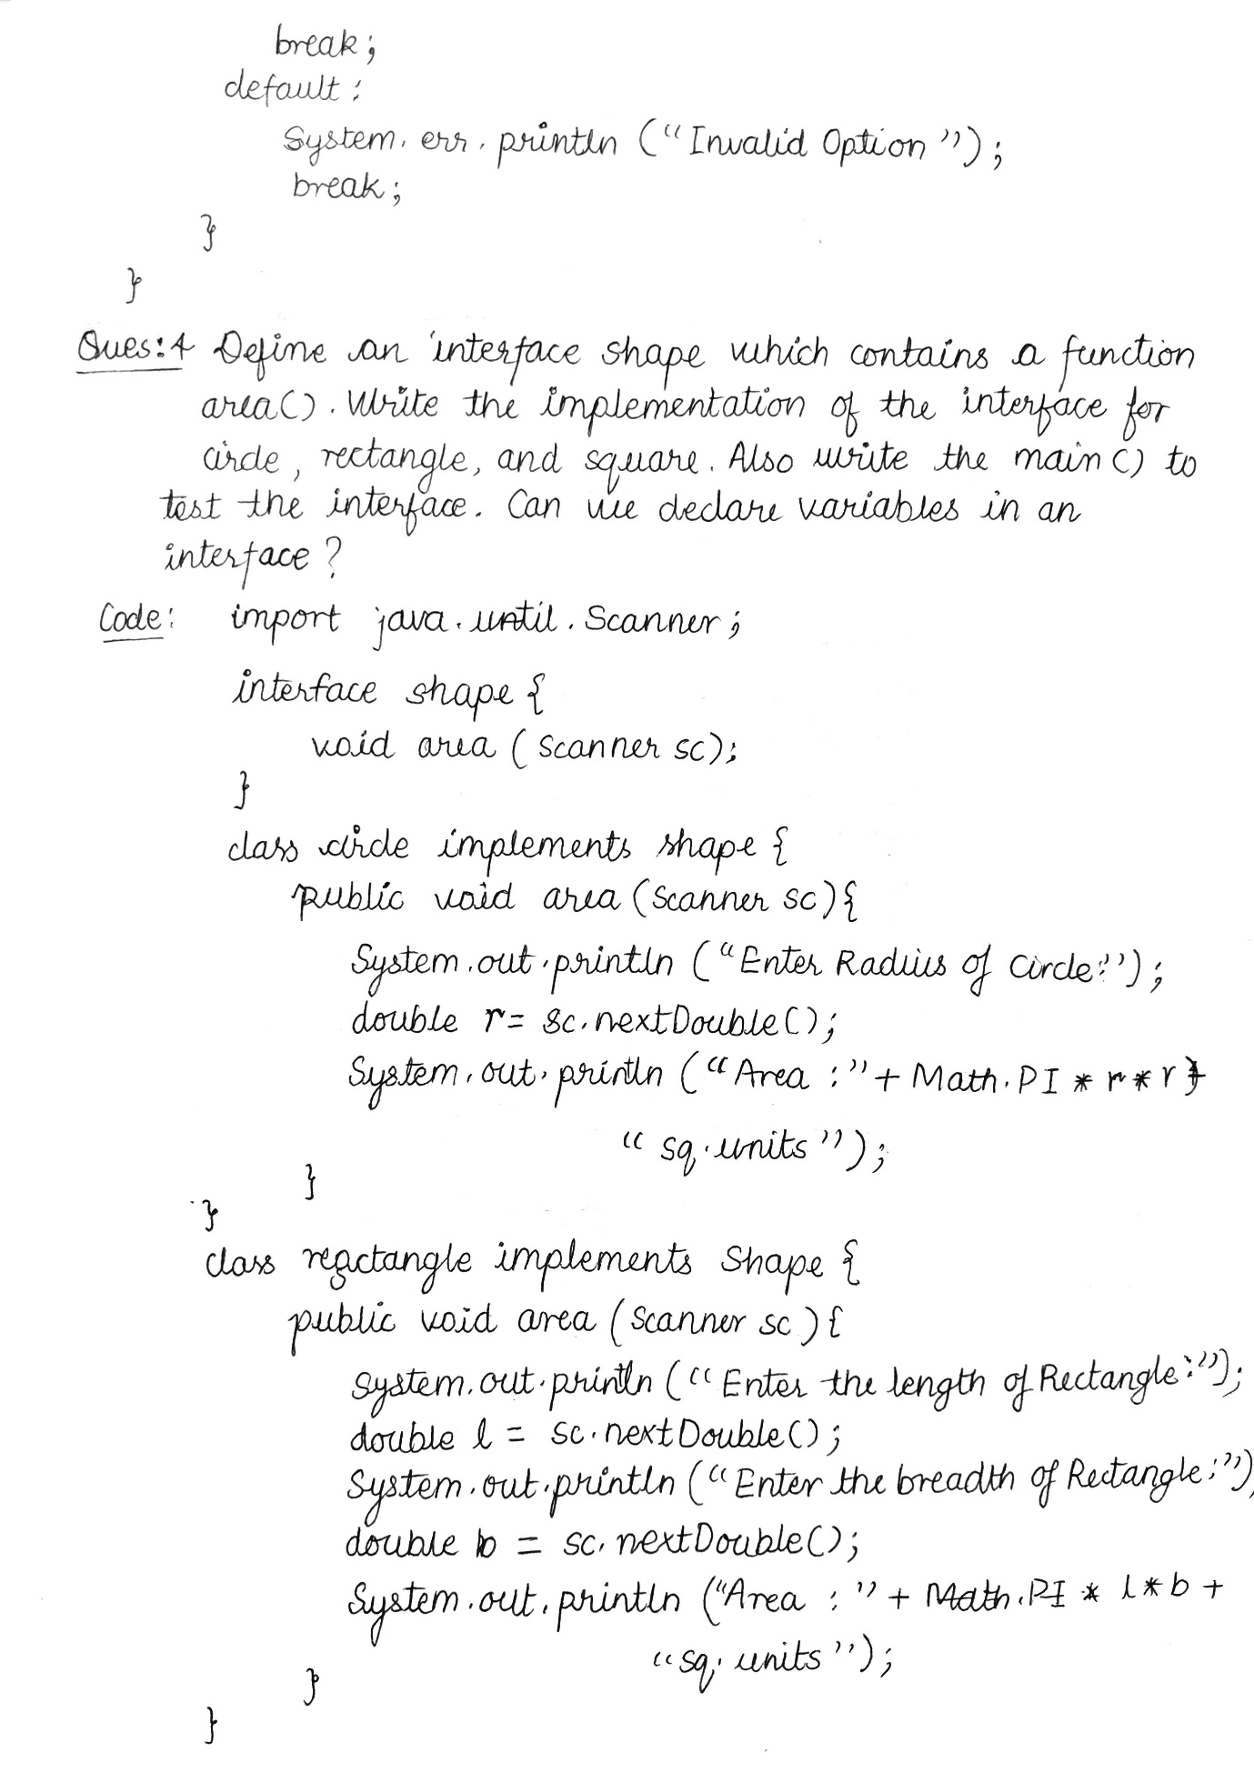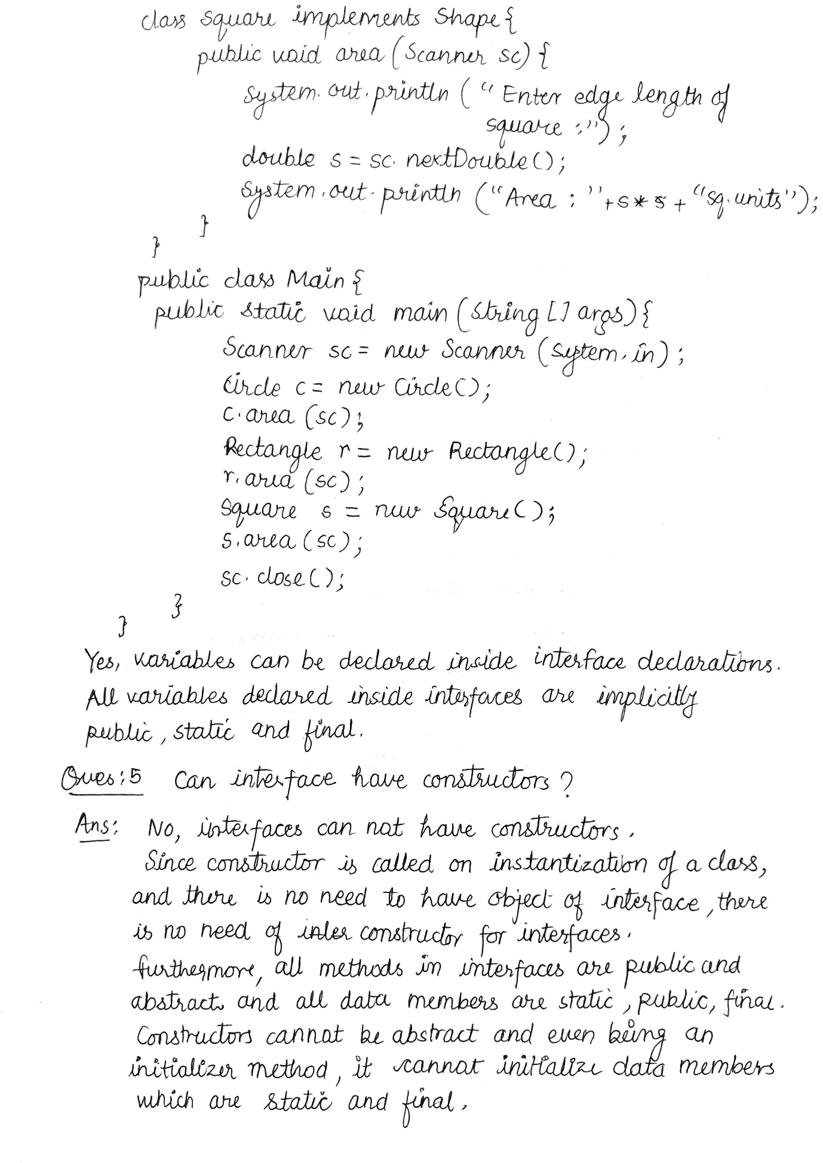

Assignment #3

Q1. What will be the output (write explanation also) of the below program?

a)

public class JavaHungry {

public static void main(String args[])

{

try

{

System.out.print("A");

int num = 99/0;

System.out.print("B");

}

catch(ArithmeticException ex)

{

System.out.print("C");

}

catch(Exception ex)

{

System.out.print("D");

}

System.out.print("E");

}

}

Output -> ACE

b)

public class JavaHungry

{

public static void main(String args[]) {

try

{

System.out.print("A");

int num = 99/0;

System.out.print("B");

}

catch(ArithmeticException ex)

{

System.out.print("C");

}

catch(Exception ex)

{

System.out.print("D");

}

finally

{

System.out.print("E");

}

System.out.print("F");

}

}

Output -> ACEF

Q2. Create an exception subclass UnderAge, which prints “Under Age” along with the age value when an object of UnderAge class is printed in the catch statement. Write a class exceptionDemo in which the method test() throws UnderAge exception if the variable age passed to it as argument is less than 18. Write main() method also to show working of the program.. (Try on machine also, if possible)

Code : UnderAge.java ->

public class UnderAge extends Exception {

private int age;

public UnderAge(int age) {

this.age = age;

}

@Override

public String getMessage() {

return "UnderAge: " + age + " is less than 18";

}

}

exceptionDemo.java ->

import java.util.Scanner;

class exceptionDemo {

static void test(int age) throws UnderAge {

if (age < 18)

throw new UnderAge(age);

}

public static void main(String[] args) {

Scanner sc = new Scanner(System.in);

System.out.print("Enter Age: ");

int age = sc.nextInt();

try {

test(age);

System.out.println("Test Successful");

} catch (UnderAge e) {

System.err.println(e.getMessage());

System.out.println("Test Unsuccessful");

} finally {

sc.close();

}

}

}

Q3. Write a program to implement stack. Use exception handling to manage underflow and overflow conditions. (Try on machine also, if possible)

Code :

public class StackException extends Exception {

final private String message;

public StackException(String message) {

this.message = message;

}

@Override

public String getMessage() {

return this.message;

}

}

public class Stack {

static final int size;

int top;

int arr[];

boolean isEmpty() {

return (top < 0);

}

public Stack(int size) {

this.top = -1;

this.size = size;

this.arr = new int[this.size];

}

public void push(int x) throws StackException {

if (top >= (this.size - 1)) {

throw new StackException("Stack Overflow : could not push "+x);

}

else {

this.arr[++this.top] = x;

System.out.println(x + " pushed into stack");

}

}

public int pop() throws StackException{

if (top < 0) {

throw new StackException("Stack Underflow: could not pop");

return 0;

}

else {

return this.arr[this.top--];

}

}

public int peek() {

if (top < 0) {

throw StackException("Stack Underflow: could not peek");

return 0;

}

else {

return this.arr[this.top];

}

}

@Override

public String toString(){

return “Stack size = “+this.size;

}

}

// Driver code

public class Main {

public static void main(String args[]) {

Stack s = new Stack(3);

s.push(10);

System.out.println(s);

s.push(20);

s.push(30);

System.out.println(s.pop() + " Popped from stack");

System.out.println(s.peek() + “ is on the top of stack”);

s.push(40);

s.push(50);

}

}

**Output:** 10 pushed into stack

Stack size = 3

20 pushed into stack

30 pushed into stack

30 popped from stack

20 is on the top of stack

40 pushed into the stack

Error: Stack Overflow: could not push 50

Q4. Can we write only try block without catch and finally blocks?

Ans: No, it shall result in a compilation error *error: 'try' without 'catch', 'finally' or resource declarations.*

The try block must be followed by either a *catch* or *finally* block. We can remove either catch block or finally block but not both of them. An exception can be made in the case of *try-with-resources* blocks which does not necessarily need to be followed by catch or finally blocks.

Q5. There are three statements in a try block – statement1, statement2 and statement3. After that there is a catch block to catch the exceptions occurred in the try block. Assume that exception has occurred in statement2. Does statement3 get executed or not?

Ans: In case that statement2 throws an exception in the try block, the execution skips to the code in the catch block.

Hence, statement3 will not be executed.

Assignment #4

Q1. What will be the output (write explanation also) of the below program?

import java.io.*;

class Chararrayinput

{

public static void main(String[] args)

{

String obj = "abcdef";

int length = obj.length();

char c[] = new char[length];

obj.getChars(0, length, c, 0);

CharArrayReader input1 = new CharArrayReader(c);

CharArrayReader input2 = new CharArrayReader(c, 0, 3);

int i;

try

{

while((i = input2.read()) != -1)

{

System.out.print((char)i);

}

}

catch (IOException e)

{

e.printStackTrace();

}

}

}

**Output : abc**

Q2. Write a program that copies content of one file to another. Pass the names of the files through command-line arguments.

Code:

import java.io.*;

public class FileCopy {

public static void main(String[] args) throws Exception {

if (args.length != 2) {

System.err.println("Correct Usage: java Copy <src> <dest>");

} else {

int i;

FileInputStream fin = new FileInputStream(args[0]);

FileOutputStream fout = new FileOutputStream(args[1]);

System.out.println("Copying contents of " + args[0] + " to " + args[1] + “………”);

while ((i = fin.read()) != -1) {

fout.write(i);

}

fin.close();

fout.close();

System.out.println(“Copying Done!”);

}

}

}

Q3. Write a program to read a file and display only those lines that have the first two characters as '//' (Use try with resources).

Code:

import java.io.*;

public class FileAnalyzer {

static boolean analyzeLine(String line) {

if (line.length() >= 2)

return line.substring(0, 2).equals("//");

return false;

}

public static void main(String[] args) {

if (args.length != 1) {

System.err.println("Correct Usage: java FileAnalyze <file_name>");

} else {

try (BufferedReader br = new BufferedReader(new FileReader(args[0]))) {

String str;

while ((str = br.readLine()) != null) {

//Removing leading and trailing space

str = str.trim();

//Checking condition

if (analyzeLine(str)) {

System.out.println(str);

}

}

br.close();

} catch (Exception e) {

System.err.println(e.getMessage());

}

}

}

}

Q4. How do you handle console output using PrintWriter class?

Ans: To write to the console by using a PrintWriter, we specify System.out for the output stream and flush the stream after each newline. For example, this line of code creates a PrintWriter that is connected to console output:

PrintWriter pw = new PrintWriter(System.out, true);

Here, the first argument is the output steam object and second argument (flushOnNewline) controls whether Java flushes the output stream every time a println( ) method is called.

The following application illustrates using a PrintWriter to handle console output:

// Demonstrate PrintWriter

import java.io.*;

public class PrintWriterDemo {

public static void main(String args[]) {

PrintWriter pw = new PrintWriter(System.out, true);

pw.println("This is a string");

int i = -7;

pw.println(i);

double d = 4.5e-7;

pw.println(d);

}

}

The output from this program is shown here:

This is a string

-7

4.5E-7

Q5. How do you read 1) characters 2) a string , using BufferedReader class?

Ans: (i) To read a character from a BufferedReader, use read( ). The version of read() that we will be using is

int read( ) throws IOException

Each time that read( ) is called, it reads a character from the input stream and returns it as an integer value. It returns –1 when the end of the stream is encountered. As we can see, it can throw an IOException.

The following program demonstrates read( ) by reading characters from the console

until the user types a "q.”

import java.io.*;

class BRRead {

public static void main(String args[])

throws IOException{

char c;

BufferedReader br = new

BufferedReader(new InputStreamReader(System.in));

System.out.println("Enter characters, 'q' to quit.");

// read characters

do {

c = (char) br.read();

System.out.println(c);

} while(c != 'q');

}

}

(ii) To read a string from the keyboard, use the version of readLine( ) that is a member of the BufferedReader class. Its general form is shown here:

String readLine( ) throws IOException

As we can see, it returns a String object.

The following program demonstrates BufferedReader and the readLine( ) method;

the program reads and displays lines of text until you enter the word “stop”:

// Read a string from console using a BufferedReader.

import java.io.*;

class BRReadLines {

public static void main(String args[]) throws IOException {

// create a BufferedReader using System.in

BufferedReader br = new BufferedReader(new InputStreamReader(System.in));

String str;

System.out.println("Enter lines of text.");

System.out.println("Enter 'stop' to quit.");

do {

str = br.readLine();

System.out.println(str);

} while(!str.equals("stop"));

}

}

Q6. Write name and meaning of all stream classes discussed in reference book.

Ans: Input Stream Classes ->

|  |  |
| --- | --- |
| Class | Description |
| BufferedInputStream | contains methods to read bytes from the buffer (memory area) |
| ByteArrayInputStream | contains methods to read bytes from a byte array |
| DataInputStream | contains methods to read Java primitive data types |
| FileInputStream | contains methods to read bytes from a file |
| FilterInputStream | contains methods to read bytes from other input streams which it uses as its basic source of data |
| ObjectInputStream | contains methods to read objects |
| PipedInputStream | contains methods to read from a piped output stream. A piped input stream must be connected to a piped output stream |
| SequenceInputStream | contains methods to concatenate multiple input streams and then read from the combined stream |

Output Stream Classes ->

|  |  |
| --- | --- |
| Class | Description |
| BufferedOutputStream | Contains methods to write bytes into the buffer |
| ByteArrayOutputStream | Contains methods to write bytes into a byte array |
| DataOutputStream | Contains methods to write Java primitive data types |
| FileOutputStream | Contains methods to write bytes to a file |
| FilterOutputStream | Contains methods to write to other output streams |
| ObjectOutputStream | Contains methods to write objects |
| PipedOutputStream | Contains methods to write to a piped output stream |
| PrintStream | Contains methods to print Java primitive data types |

Assignment #5

Q1. Write a program that copies content of one file to another. Pass the names of the files through command-line arguments.

Code:

import java.io.*;

public class FileCopy {

public static void main(String[] args) throws Exception {

if (args.length != 2) {

System.err.println("Correct Usage: java Copy <src> <dest>");

} else {

int i;

FileInputStream fin = new FileInputStream(args[0]);

FileOutputStream fout = new FileOutputStream(args[1]);

System.out.println("Copying contents of " + args[0] + " to " + args[1] + “………”);

while ((i = fin.read()) != -1) {

fout.write(i);

}

fin.close();

fout.close();

System.out.println(“Copying Done!”);

}

}

}

Q2. Write a program in Java (using try-with-resources functionality) to do the following:

i) open two files "exam1.txt" and "exam2.txt". Accept file names through command-line arguments.

ii) exit the program if any of the two files is unable to open.

iii) append contents of "exam1.txt" to "exam2.txt".

iv) re-write contents of "exam2.txt" after removing all white spaces from the updated content (without using built-in methods).

Code:

import java.io.*;

public class Main {

public static void main(String[] args) {

if (args.length != 2) {

System.out.println("Correct Usage: java Main <file1> <file2>");

System.exit(1);

}

try (BufferedReader finA = new BufferedReader(new FileReader(args[0]));

BufferedWriter foutB = new BufferedWriter(new FileWriter(args[1], true))) {

String s;

while ((s = finA.readLine()) != null) {

foutB.newLine();

foutB.write(s);

foutB.flush();

}

System.out.println("Task 1 Done...");

} catch (Exception e) {

System.out.println("Could not open one of the files, exiting...");

System.exit(-1);

}

try (BufferedReader finB = new BufferedReader(new FileReader(args[1]))) {

String s, o = "";

while ((s = finB.readLine()) != null) {

char[] array = s.toCharArray();

for (int i = 0; i < s.length(); i++)

switch (array[i]) {

case ' ':

case '\t':

case '\n':

case '\r':

break;

default:

o += array[i];

break;

}

}

try (BufferedWriter foutB = new BufferedWriter(new FileWriter(args[1]))) {

foutB.write(o);

}

System.out.println("Task 2 Done!");

} catch (Exception e) {

System.out.println("Could not open one of the files, exiting...");

System.exit(-1);

}

}

}

Q3. What is Delegation Event Model? Explain its components in short.

Ans: **Delegation Event Model** : The modern approach to handling events is based on the delegation event model, which defines standard and consistent mechanisms to generate and process events. Its concept is quite simple: a source generates an event and sends it to one or more listeners. In this scheme, the listener simply waits until it receives an event. Once an event is received, the listener processes the event and then returns. The advantage of this design is that the application logic that processes events is cleanly separated from the user interface logic that generates those events. A user interface element is able to “delegate” the processing of an event to a separate piece of code.

The components of the Delegation Event Model are as follows :

Events : In the delegation model, an event is an object that describes a state change in a source. It can be generated as a consequence of a person interacting with the elements in a graphical user interface. Events may also occur that are not directly caused by interactions with a user interface.

Event Sources : A source is an object that generates an event. This occurs when the internal state of that object changes in some way. Sources may generate more than one type of event. A source must register listeners in order for the listeners to receive notifications about a specific type of event. Each type of event has its own registration method.

Event Listeners : A listener is an object that is notified when an event occurs. It has two major requirements. First, it must have been registered with one or more sources to receive notifications about specific types of events. Second, it must implement methods to receive and process these notifications.

Q4. Write commonly used Event Classes in java.awt.event and their description.

Ans.

|  |  |
| --- | --- |
| Event Class | Description |
| ActionEvent | Generated when a button is pressed, a list item is double-clicked, or a menu item is selected. |
| AdjustmentEvent | Generated when a scroll bar is manipulated. |
| ComponentEvent | Generated when a component is hidden, moved, resized, or becomes visible. |
| ContainerEvent | Generated when a component is added to or removed from a container. |
| FocusEvent | Generated when a component gains or loses keyboard focus. |
| InputEvent | Abstract superclass for all component input event classes. |
| ItemEvent | Generated when a check box or list item is clicked; also occurs when a choice selection is made or a checkable menu item is selected or deselected. |
| KeyEvent | Generated when input is received from the keyboard. |
| MouseEvent | Generated when the mouse is dragged, moved, clicked, pressed, or released; also generated when the mouse enters or exits a component. |
| MouseWheelEvent | Generated when the mouse wheel is moved. |
| TextEvent | Generated when the value of a text area or text field is changed. |
| WindowEvent | Generated when a window is activated, closed, deactivated, deiconified, iconified, opened, or quit. |

Assignment #6

Q1. Write different constants and their description available in AdjustmentEvent class.

Ans: The different constants and their meanings of AdjustmentEvent class are shown below :

|  |  |
| --- | --- |
| Constant | Description |
| BLOCK_DECREMENT | The user clicked inside the scroll bar to decrease its value. |
| BLOCK_INCREMENT | The user clicked inside the scroll bar to increase its value. |
| TRACK | The slider was dragged. |
| UNIT_DECREMENT | The button at the end of the scroll bar was clicked to decrease its value. |
| UNIT_INCREMENT | The button at the end of the scroll bar was clicked to increase its value. |
| ADJUSTMENT_VALUE_CHANGED | An integer constant, that indicates that a change has occurred. |

Q2. Write different constants and their description available in ComponentEvent class.

Ans: The different constants and their meanings of ComponentEvent class are shown below :

|  |  |
| --- | --- |
| Constant | Description |
| COMPONENT_HIDDEN | The component was hidden. |
| COMPONENT_MOVED | The component was moved. |
| COMPONENT_RESIZED | The component was resized. |
| COMPONENT_SHOWN | The component became visible. |

Q3. Explain syntax of all constructors available in ContainerEvent and FocusEvent class.

Ans:

**Constructors in ContainerEvent Class**

ContainerEvent(Component src, int type, Component comp)

It instantiates a ContainerEvent object.

The first argument src is a reference to the Component object (container) that originated the event. This method throws an IllegalArgumentException if src is null. The second argument type is an integer indicating the type of event. The third argument comp is the reference to the Component that was added or removed.

**Constructors in FocusEvent Class**

FocusEvent(Component src, int type)

It instantiates a FocusEvent object and identifies it as a permanent change in focus.

Here, the first argument src is the Component that originated the event. This method throws an IllegalArgumentException if src is null. The second argument type is an integer indicating the type of event.

FocusEvent(Component src, int type, boolean temporaryFlag)

It instantiates a FocusEvent object and identifies whether or not the change is temporary.

Here, the first argument src is the Component that originated the event. This method throws an IllegalArgumentException if src is null. The second argument type is an integer indicating the type of event. The third argument temporaryFlag is a boolean value which is set to true if the focus change is temporary and is false otherwise.

FocusEvent(Component src, int type, boolean temporaryFlag, Component other)

It instantiates a FocusEvent object with the specified temporary state and opposite Component. The opposite Component is the other Component involved in this focus change. For a FOCUS_GAINED event, this is the Component that lost focus. For a FOCUS_LOST event, this is the Component that gained focus. If this focus change occurs with a native application, with a Java application in a different VM, or with no other Component, then the opposite Component is null.

Here, the first argument src is the Component that originated the event. This method throws an IllegalArgumentException if src is null. The second argument type is an integer indicating the type of event. The third argument temporaryFlag is a boolean value which is set to true if the focus change is temporary and is false otherwise. The fourth argument other is the opposite Component involved in the focus change, or null.

Q4. Write the name of constants present in InputEvent class.

Ans:

1. ALT_MASK
2. ALT_GRAPH_MASK
3. BUTTON1_MASK
4. BUTTON2_MASK
5. BUTTON3_MASK
6. CTRL_MASK
7. META_MASK
8. SHIFT_MASK
9. ALT_DOWN_MASK
10. ALT_GRAPH_DOWN_MASK
11. BUTTON1_DOWN_MASK
12. BUTTON2_DOWN_MASK
13. BUTTON3_DOWN_MASK
14. CTRL_DOWN_MASK
15. META_DOWN_MASK
16. SHIFT_DOWN_MASK

Q5. List all the constants present in KeyEvent class.

Ans:

1. VK_ALT
2. VK_DOWN
3. VK_LEFT
4. VK_RIGHT
5. VK_CANCEL
6. VK_ENTER
7. VK_PAGE_DOWN
8. VK_SHIFT
9. VK_CONTROL
10. VK_ESCAPE
11. VK_PAGE_UP
12. VK_UP

Q6. List all the constants present in MouseEvent class.

Ans:

1. MOUSE_CLICKED
2. MOUSE_DRAGGED
3. MOUSE_ENTERED
4. MOUSE_EXITED
5. MOUSE_MOVED
6. MOUSE_PRESSED
7. MOUSE_RELEASED
8. MOUSE_WHEEL

Q7. List all the constants and their meaning present in WindowEvent

class.

Ans:

1. WINDOW_ACTIVATED
2. WINDOW_CLOSED
3. WINDOW_CLOSING
4. WINDOW_DEACTIVATED
5. WINDOW_DEICONIFIED
6. WINDOW_GAINED_FOCUS
7. WINDOW_ICONIFIED
8. WINDOW_LOST_FOCUS
9. WINDOW_OPENED
10. WINDOW_STATE_CHANGED